Practical-8

Name:-Vishwajit Kate

Reg. No:-2020BIT011

# Write a Program to implement,

# Floyd-Warshall

# Knapsack problem

# Write a Algorithm with complete Simulation

# 1) Floyd-Warshall

# Code:-

// 2020BIT011

#include <stdio.h>

#define nV 4

#define INF 999

void printMatrix(int matrix[][nV]);

void floydWarshall(int graph[][nV]) {

int matrix[nV][nV], i, j, k;

for (i = 0; i < nV; i++)

for (j = 0; j < nV; j++)

matrix[i][j] = graph[i][j];

for (k = 0; k < nV; k++) {

for (i = 0; i < nV; i++) {

for (j = 0; j < nV; j++) {

if (matrix[i][k] + matrix[k][j] < matrix[i][j])

matrix[i][j] = matrix[i][k] + matrix[k][j];

}

}

}

printMatrix(matrix);

}

void printMatrix(int matrix[][nV]) {

for (int i = 0; i < nV; i++) {

for (int j = 0; j < nV; j++) {

if (matrix[i][j] == INF)

printf("%4s", "INF");

else

printf("%4d", matrix[i][j]);

}

printf("\n");

}

}

int main() {

int graph[nV][nV] = {{0, 3, INF, 5},

{2, 0, INF, 4},

{INF, 1, 0, INF},

{INF, INF, 2, 0}};

floydWarshall(graph);

}}**Output:**

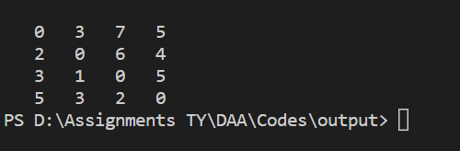

**Simulation:**

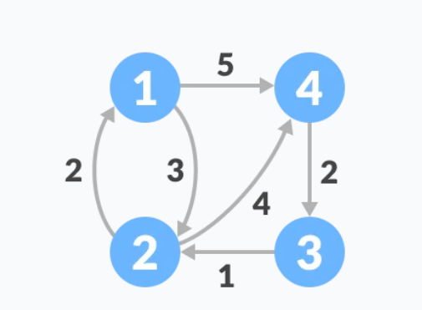

# 2) Knapsack problem

# Code:-

# // 2020BIT011

# #include <stdio.h>

# 

# int max(int a, int b) { return (a > b) ? a : b; }

# 

# int knapSack(int W, int wt[], int val[], int n)

# {

# 

# if (n == 0 || W == 0)

# return 0;

# 

# 

# if (wt[n - 1] > W)

# return knapSack(W, wt, val, n - 1);

# else

# return max(

# val[n - 1]

# + knapSack(W - wt[n - 1], wt, val, n - 1),

# knapSack(W, wt, val, n - 1));

# }

# 

# int main()

# {

# int profit[] = { 60, 100, 120 };

# int weight[] = { 10, 20, 30 };

# int W = 50;

# int n = sizeof(profit) / sizeof(profit[0]);

# printf("%d", knapSack(W, weight, profit, n));

# return 0;

# }**Output:**

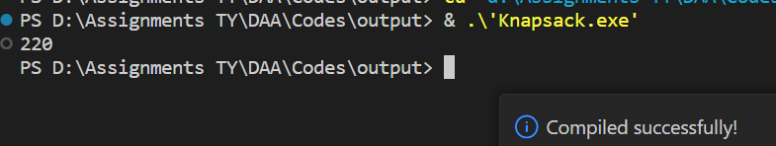

**Simulation:**

